**In-Class Task 1 – Part 2 Instructions: Modify the Test Scores application**

In this In-Class Task, you’ll modify the Test Scores application, so it provides for four test scores and displays the results in a dialog box like the one that follows. Estimated time: 10 to 20 minutes.

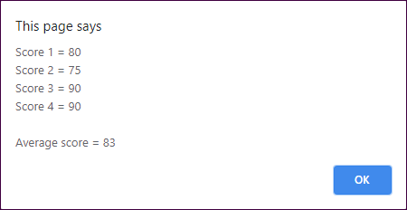

1. Open the application in this folder:

Evaluations\In-Class Tasks\In-Class Task 1\test_scores.zip

1. Run the application and note that it works like the one in the book and that it writes the results to the browser page. Then, review the code in the JavaScript file, and note that it’s slightly different than the code in the book, although it gets the same results.
2. Modify the application so it provides for a fourth test score.

Modify the application so it displays the results in a dialog box like the one above, as well as in the browser page after the dialog box is closed.